Experiment: Create a Virtual Hard Disk and Allocate Storage using VMware Workstation

Aim
To create a Virtual Hard Disk and allocate storage for a virtual machine using VMware Workstation.

Procedure
Step 1: Open VMware Workstation.
Step 2: Select the virtual machine and open Virtual Machine Settings.
Step 3: Set Memory to 2 GB.
Step 4: Configure Processor as 1 CPU and 1 Core.
Step 5: Allocate a 15 GB Virtual Hard Disk.
Step 6: Attach the Ubuntu ISO file through CD/DVD settings.
Step 7: Create a snapshot after configuration.

Memory Configuration
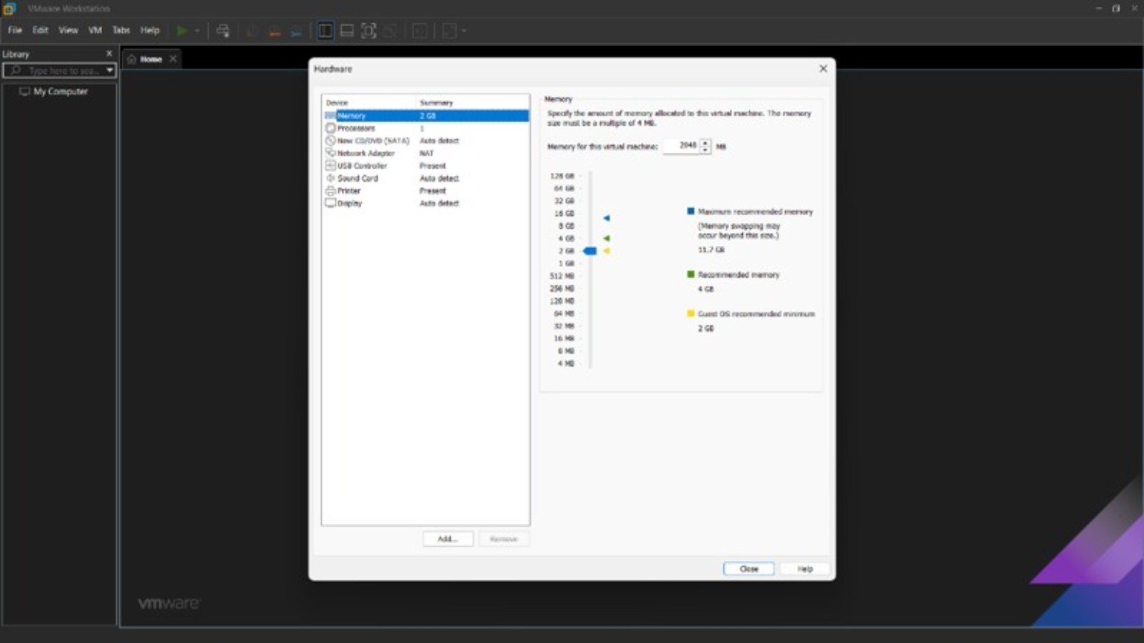

Processor Configuration
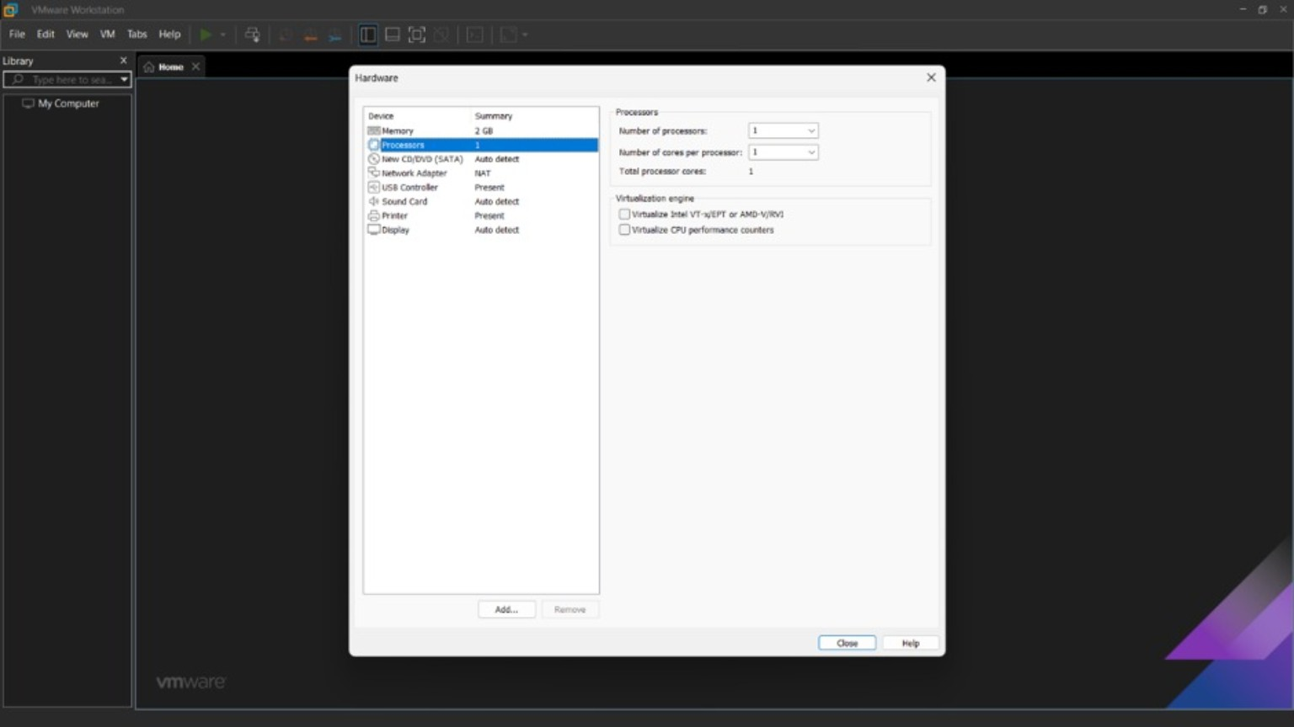

Hard Disk Allocation
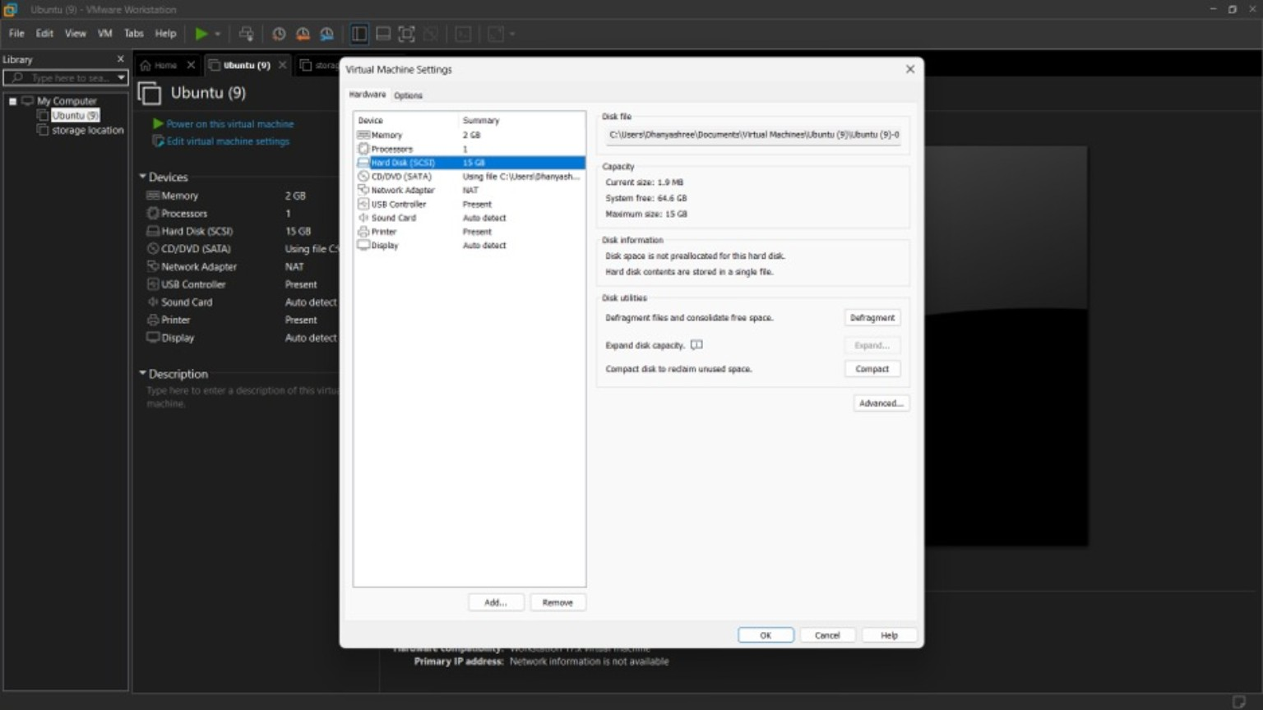

ISO File Configuration
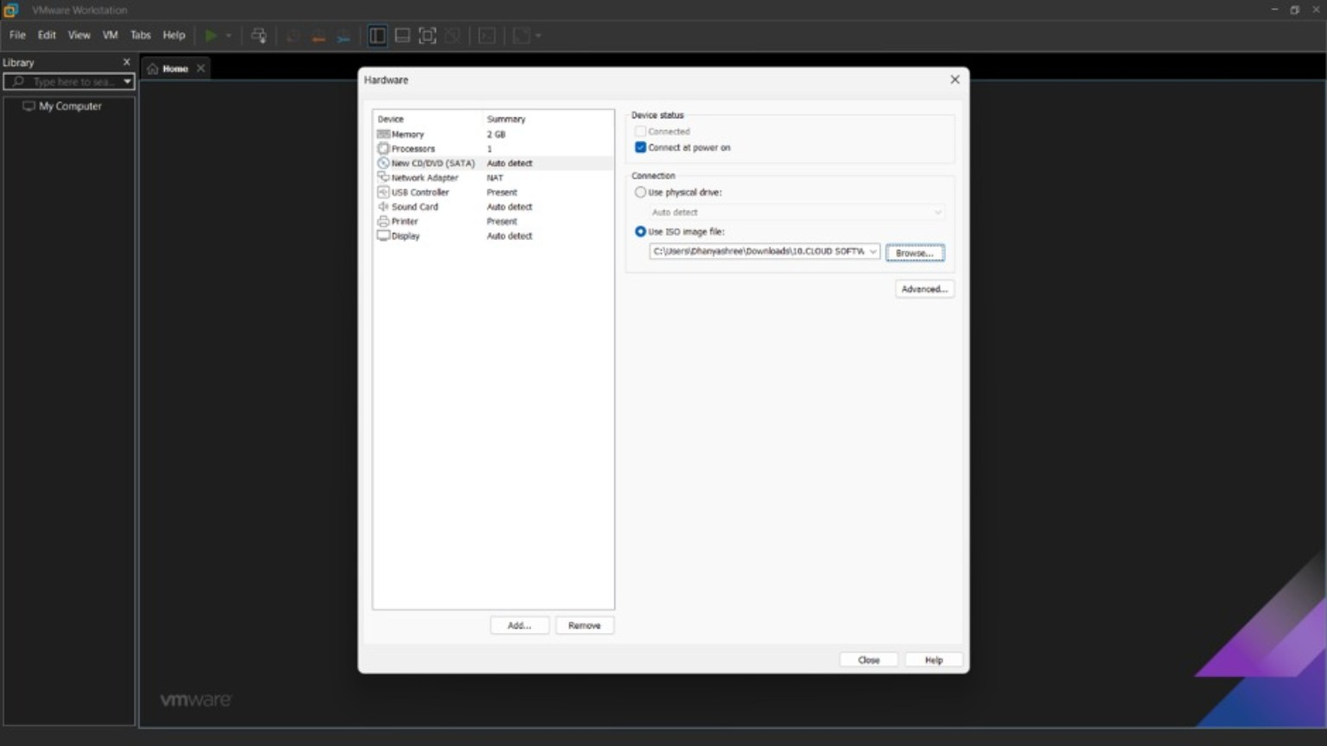

Snapshot Creation
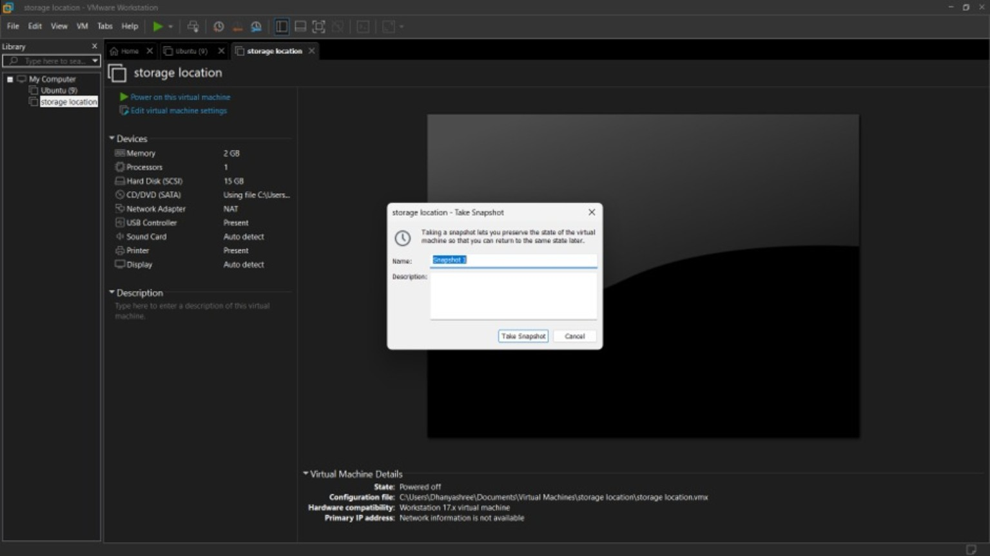

Snapshot Completed
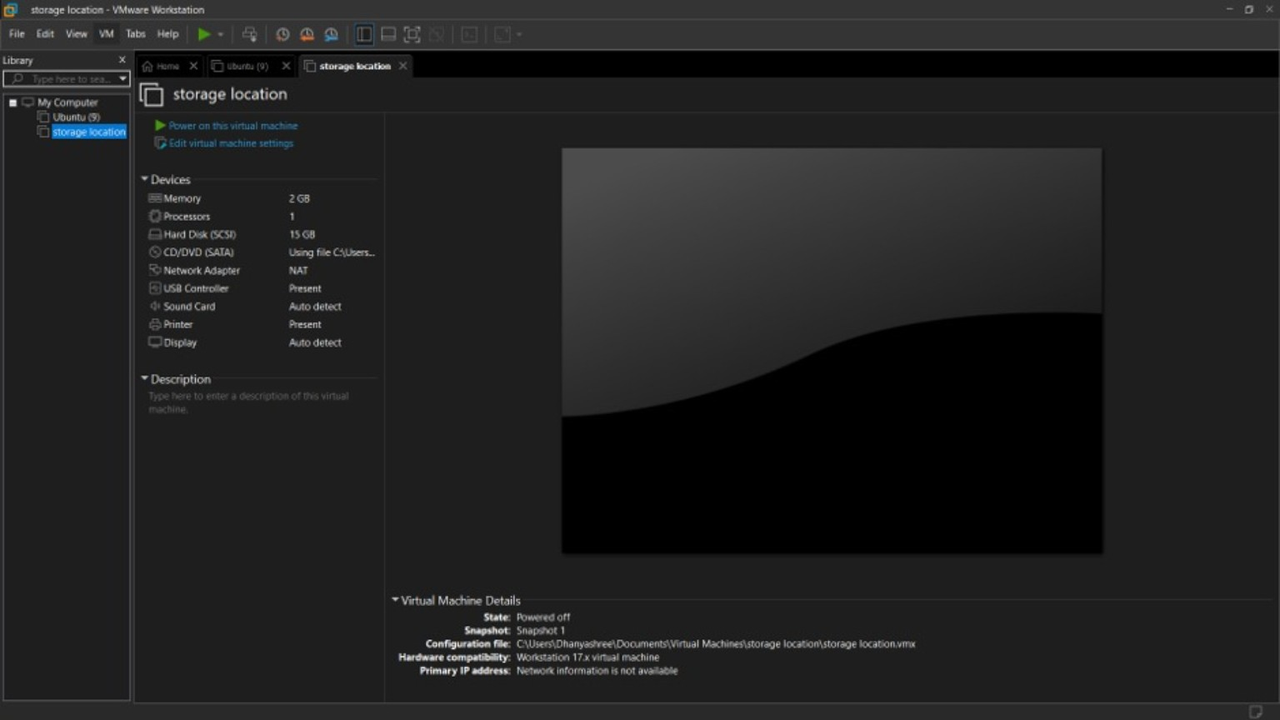

Observation
The virtual machine was successfully configured with 2 GB RAM, 1 CPU and a 15 GB virtual hard disk. The ISO image was attached and a snapshot was created successfully.

Result
Thus, the Virtual Hard Disk was created and storage was allocated successfully using VMware Workstation.

